STLC Workbook

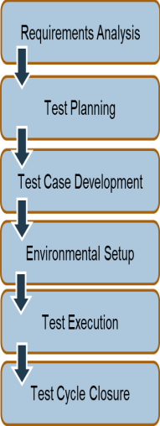

Requirements are analyzed to determine how they can be validated.

Planning for the test phase. Choose the tool and resources needed

Creation, verification, and rework of test cases and test scripts.

Determines the software and hardware conditions under which a work product is to be tested.

______________________________________________

Testing performed per test plans and test cases.

Bugs reported to the development team for correction.

Retesting performed after correction.

Evaluate cycle completion criteria based on time, test coverage, cost, software, critical business objectives, and quality.

| Entry  Criteria | Gives the prerequisite items that must be completed before testing can *begin*. |
| --- | --- |
| Exit  Criteria | Defines the items that must be completed before testing can be *concluded*. |

**Requirements Analysis**

**Requirement Types**

| Functional | define what the software must accomplish. |
| --- | --- |
| Non-functional | define availability, capacity, continuity, and security. |
| Requirements Traceability  Matrix (RTM) | a document that demonstrates the relationship between requirements and other artifacts |

**Requirements Analysis Stage Detail**

| Entry Criteria  Requirements  Document  available (  functional and nonfunctional).  Acceptance criteria  defined.  Application  architectural  document  available. | Activity  - Analyze business functionality to know the business modules and module-specific functionalities.  - Identify all transactions in the modules.  - Identify all the user profiles.  - Gather user interface/authentication and geographic-spread requirements.  - Identify types of tests to be performed.  - Gather details about testing priorities and focus.  - Prepare Requirement Traceability Matrix(RTM).  - Identify test environment details where testing is supposed to be carried out.  - Automation feasibility analysis (if required). | Exit Criteria  - Signed-off RTM.  - Signed-off test automation feasibility report. | Deliverables  - RTM.  - Automation  Feasibility report (if applicable).  -List of questions with all answers to be resolved from business (e.g., testable requirements). |
| --- | --- | --- | --- |

**Test Planning**

Types of Testing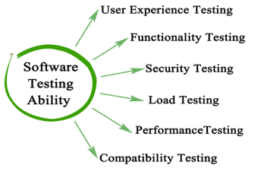

**Requirements Planning Stage Detail**

| Entry Criteria  Requirements  Document.  Requirement Traceability Matrix (RTM).  Test automation feasibility report. | Activity  - Analyze various approaches available.  - Finalize on the best-suited approach.  - Prepare test plan/strategy document for various types of testing.  - Test tool selection.  - Test effort estimation.  Determine resource planning and roles and responsibilities. | Exit Criteria  - Approved Test plan/strategy document.  - Signed-off effort estimation document. | Deliverables  - Test plan/strategy document.  - Effort estimation document. |
| --- | --- | --- | --- |

04

**Test Case Development**

| Test Case | Creation, verification, and rework of test cases and test scripts. |
| --- | --- |
| Test Data | [Test data](https://www.guru99.com/software-testing-test-data.html), is identified/created and reviewed, and then may be reworked. |

**Test Case Development Stage Detail**

| Entry Criteria  Requirements  Document.  RTM and Test Plan.  Test automation feasibility report. | Activity  - Create test cases, test design, and automation scripts (where applicable). - Review and baseline test cases and scripts.  - Create test data. | Exit Criteria  - Reviewed and signed test  cases/scripts. - Reviewed and signed test data. | Deliverables  - Test cases and scripts.  - Test data. |
| --- | --- | --- | --- |

**Test Environment Setup**

| Test  Environment | Determines the software and hardware conditions under which a work product is to be tested. |
| --- | --- |
| Most important  thing about a test environment | The Test Environment is set up. |

**Test Execution Stage Detail**

| Entry Criteria  - System design and  architecture documents are available.  - Environment set-up plan is available. | Activity  - Understand the required architecture, environment setup.  - Prepare hardware and software development requirement list.  - Finalize connectivity requirements.  - Prepare environment setup checklist.  - Set up test environment and test data.  - Perform smoke test on the build.  - Accept/reject the build depending on smoke test result. | Exit Criteria  - Environment  setup is working per the plan and checklist.  - Test data setup is  complete.  - Smoke test is successful. | Deliverables  - Environment ready with  test data setup.  - Smoke test results. |
| --- | --- | --- | --- |

**Test Execution**

| Smoke Test | Smoke testing is a software testing process that determines whether or not the deployed software build is stable. |
| --- | --- |
| Regression Testing | Regression testing is a type of software testing, wherein test cases are re-executed to check that the previous functionality of the application is working properly, and that the new changes have not produced any bugs. |

**Test Environment Stage Detail**

| Entry Criteria  - Baselined RTM,  [Test Plan](https://www.guru99.com/what-everybody-ought-to-know-about-test-planing.html), and Test case/scripts are available.  - Test environment is ready.  - Test data setup is done.  - Unit/Integration test report for the build to be tested is available. | Activity  - Execute tests per plan.  - Document test results and log defects for failed cases.  - Update test plans/test cases, if necessary.  - Map defects to test cases in RTM Retest the defect fixes.  - [Regression Testing](https://www.guru99.com/regression-testing.html) of application.  - Track the defects to closure. | Exit Criteria  - All tests planned are executed.  - Defects logged and tracked to closure. | Deliverables  - Completed RTM with execution status.  - Test cases updated with results.  - Defect reports. |
| --- | --- | --- | --- |

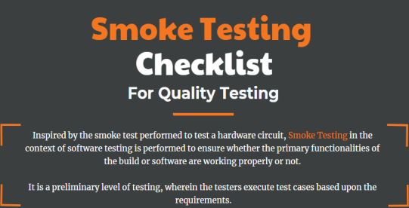

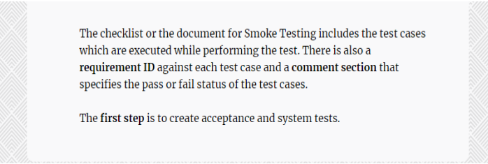

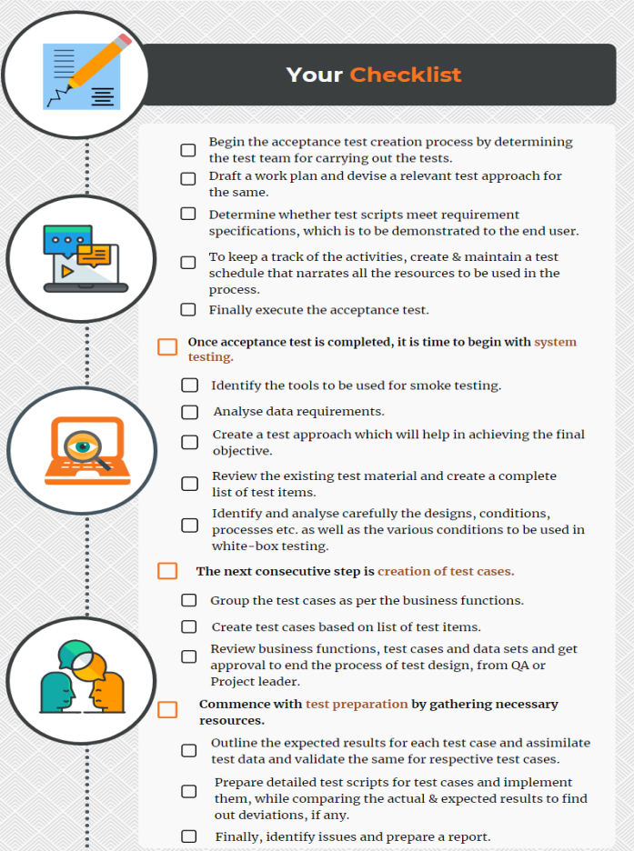

**Test Cycle Closure**

Test Cycle Closure Stage Detail

| Entry Criteria  Testing has been completed.  Test results are available.  Defect logs are available. | Activity  - Evaluate cycle completion criteria based on time, test, cost, software quality, and critical business objectives.  - Prepare test metrics based on the above parameters.  - Document the learning out of the project.  - Prepare test closure report.  - Provide a qualitative and quantitative quality report of the to the customer.  - Review test result analysis to find out the defect distribution by type and severity. | Exit Criteria  N/A | Deliverables  - Test Closure Report. |
| --- | --- | --- | --- |